In variables.tf file

variable "ec2_instance_type" {

  description = "EC2 Instance Type"

  type        = list(string)

  default     = ["t3.micro", "t3.small", "t3.large"]

in ec2…tf file, change

 instance_type          = var.ec2_instance_type[0]

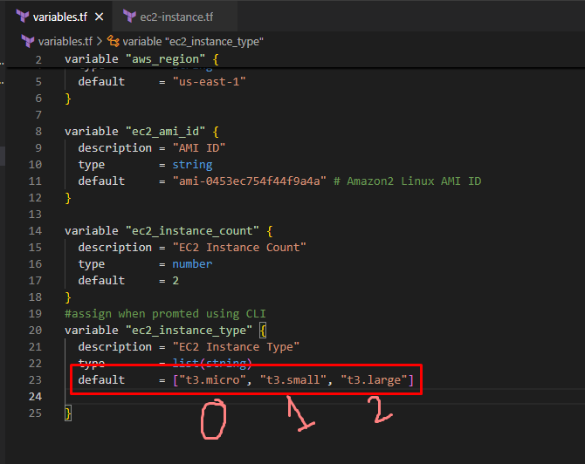

As in instance type 0 was selected, the output was t3.micro.

It 1 was selected it would be t3.small

# Implement List Function in variables.tf

variable "ec2_instance_type" {

  description = "EC2 Instance Type"

  type = list(string)

  default = ["t3.micro", "t3.small", "t3.medium"]

}

# Reference Values from List in ec2-instance.tf

instance_type = var.ec2_instance_type[0] --> t3.micro

instance_type = var.ec2_instance_type[1] --> t3.small

instance_type = var.ec2_instance_type[2] --> t3.medium

[**Types and Values - Configuration Language | Terraform | HashiCorp Developer**](https://developer.hashicorp.com/terraform/language/expressions/types)

**Implement complex type cosntructors like `list` and `maps`**

**- **Reference Sub folder:** v8-Input-Variables-Lists-Maps**

**- [Type Constraints](https://www.terraform.io/docs/language/expressions/types.html)**